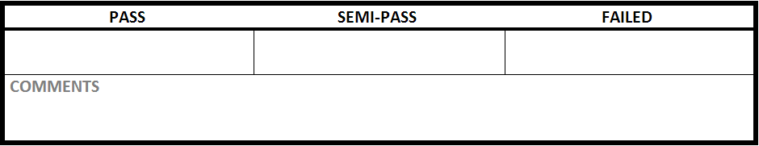

|  |  |
| --- | --- |
| Test Case #:LGN1.2 | Test Case Name:Login |
| System: Rec Warehouse | Subsystem:Login |
| Designed by: Rec Team | Design Date: October 2013 |
| Executed by: | Execution Date: |

|  |
| --- |
| Short Description: Login in with no information |

|  |
| --- |
| Preconditions: at the login screen |

|  |  |  |  |  |
| --- | --- | --- | --- | --- |
| Step | Action | Expected System Response | Pass/Fail | Comment |
| 1 | click login | displays error message saying the username is required and the PIN is incorrect |  |  |

|  |
| --- |
| Postconditions: at the login screen |